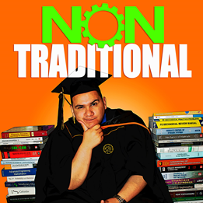
Nontraditional College Success
PODCAST GUEST RELEASE FORM

GUEST: ________________________________________________ (hereinafter “Guest”)
The above named Guest does hereby consent to the recording and distribution of reproduction(s) of the Guest's voice and performance as part of the media program entitled “Nontraditional College Success” (herein referred to as the "Program"). This is to confirm that the undersigned has agreed to be interviewed or otherwise participate in the Program, a production of the Nontraditional College Success.

As a condition of publication/broadcast and for no monetary compensation, Nontraditional College Success requests the non-exclusive worldwide rights to reproduce, distribute, and sell your oral and/or video presentation, in whole or in part, in any media, as part of this Program published under the auspices of Nontraditional College Success and to license these rights to others, in perpetuity. Nontraditional College Success shall have the right to edit and/or transcribe your presentation.

You also grant Nontraditional College Success the right to use your name, biography and likeness in connection with the Program.

You warrant that your presentation is original with you, that publication/broadcast will not infringe on the rights of others, and that you have full power to grant this license. Should your presentation/broadcast incorporate copyrighted materials of others, you warrant that you have obtained such permission from those parties for publication/broadcast by Nontraditional College Success, consistent with this Agreement.

If the foregoing terms are satisfactory, please sign and date this agreement below and return it to the Program coordinator. Execution of this Agreement does not obligate Nontraditional College Success to publish your presentation or other materials.

Initial

I, the Guest am not releasing any proprietary information from a company I work or have worked in the past. Everything stated is my opinion and my opinion only.

I am filling this form for all appearances on the show.

I hereby consent to the use of my oral and/or video presentation as described and agree with the provisions of this release form:

____________________________________________ __________________
Guest’s Signature Date

